RUBINA S SUPERSET ID:6383615

# WEEK:3 -SPRING CORE AND MAVEN

## Exercise 1: Configuring a Basic Spring Application Scenario:

Your company is developing a web application for managing a library. You need to use the Spring Framework to handle the backend operations.

## Steps:

1. Set Up a Spring Project:
   * Create a Maven project named LibraryManagement.
   * Add Spring Core dependencies in the pom.xml file.
2. Configure the Application Context:
   * Create an XML configuration file named applicationContext.xml in the src/main/resources directory.
   * Define beans for BookService and BookRepository in the XML file.
3. Define Service and Repository Classes:
   * Create a package com.library.service and add a class BookService.
   * Create a package com.library.repository and add a class BookRepository.
4. Run the Application:
   * Create a main class to load the Spring context and test the configuration.

# SOLUTION

## pom.xml

<project xmlns="<http://maven.apache.org/POM/4.0.0>" xmlns:xsi="<http://www.w3.org/2001/XMLSchema-instance>"

xsi:schemaLocation="<http://maven.apache.org/POM/4.0.0> <http://maven.apache.org/xsd/maven-4.0.0.xsd>">

<modelVersion>4.0.0</modelVersion>

<groupId>com.library</groupId>

<artifactId>LibraryManagement</artifactId>

<packaging>jar</packaging>

<version>1.0-SNAPSHOT</version>

<name>LibraryManagement</name>

<dependencies>

<dependency>

<groupId>org.springframework</groupId>

<artifactId>spring-context</artifactId>

<version>5.3.36</version>

</dependency>

<dependency>

<groupId>junit</groupId>

<artifactId>junit</artifactId>

<version>4.13.2</version>

<scope>test</scope>

</dependency>

</dependencies>

<build>

<plugins>

<plugin>

<groupId>org.codehaus.mojo</groupId>

<artifactId>exec-maven-plugin</artifactId>

<version>3.1.0</version>

<configuration>

<mainClass>com.library.main.MainApp</mainClass>

</configuration>

</plugin>

</plugins>

</build>

</project>

## MainApp.java

package com.library.main;

import com.library.service.BookService;

import org.springframework.context.ApplicationContext;

import org.springframework.context.support.ClassPathXmlApplicationContext;

public class MainApp {

public static void main(String[] args) { ApplicationContext context = new

ClassPathXmlApplicationContext("applicationContext.xml");

BookService bookService = (BookService) context.getBean("bookService"); bookService.addBook("Clean Code");

}}

## BookService.java

package com.library.service;

import com.library.repository.BookRepository; public class BookService {

private BookRepository bookRepository;

public void setBookRepository(BookRepository bookRepository) { this.bookRepository = bookRepository;

}

public void addBook(String bookName) { System.out.println("Adding book: " + bookName); bookRepository.saveBook(bookName);

}

}

## BookRepository.java

package com.library.repository; public class BookRepository {

public void saveBook(String bookName) {

System.out.println("Book \"" + bookName + "\" saved to the database.");

}

}

## applicationContext.xml

<?xml version="1.0" encoding="UTF-8"?>

<beans xmlns="<http://www.springframework.org/schema/beans>"

xmlns:xsi="<http://www.w3.org/2001/XMLSchema-instance>" xsi:schemaLocation=" <http://www.springframework.org/schema/beans> <http://www.springframework.org/schema/beans/spring-beans.xsd>">

<bean id="bookRepository" class="com.library.repository.BookRepository" />

<bean id="bookService" class="com.library.service.BookService">

<property name="bookRepository" ref="bookRepository" />

</bean>

</beans>

## AppTest.java

package com.library; import org.junit.Test;

public class AppTest { @Test

public void testApp() { System.out.println("Test executed.");

}

}

OUTPUT

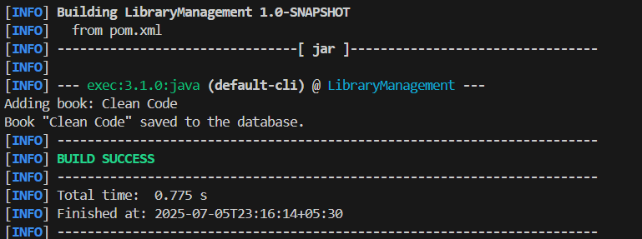

## Exercise 2: Implementing Dependency Injection Scenario:

In the library management application, you need to manage the dependencies between the BookService and BookRepository classes using Spring's IoC and DI.

## Steps:

1. Modify the XML Configuration:
   * Update applicationContext.xml to wire BookRepository into BookService.
2. Update the BookService Class:
   * Ensure that BookService class has a setter method for BookRepository.
3. Test the Configuration:

Run the LibraryManagementApplication main class to verify the dependency injection

# SOLUTION

Use Spring’s Inversion of Control (IoC) to inject the BookRepository into BookService using an XML file (applicationContext.xml).

## applicationContext.xml

<?xml version="1.0" encoding="UTF-8"?>

<beans xmlns="<http://www.springframework.org/schema/beans>" xmlns:xsi="<http://www.w3.org/2001/XMLSchema-instance>" xsi:schemaLocation=" <http://www.springframework.org/schema/beans> <http://www.springframework.org/schema/beans/spring-beans.xsd>">

<bean id="bookRepository" class="com.library.repository.BookRepository"/>

<bean id="bookService" class="com.library.service.BookService">

<property name="bookRepository" ref="bookRepository"/>

</bean>

</beans>

## BookService.java

package com.library.service;

import com.library.repository.BookRepository; public class BookService {

private BookRepository bookRepository;

public void setBookRepository(BookRepository bookRepository) { this.bookRepository = bookRepository;

}

public void addBook(String title) { System.out.println("Adding book: " + title); bookRepository.save(title);

}

}

## MainApp.java

package com.library;

import com.library.service.BookService;

import org.springframework.context.ApplicationContext;

import org.springframework.context.support.ClassPathXmlApplicationContext; public class MainApp {

public static void main(String[] args) { ApplicationContext context = new

ClassPathXmlApplicationContext("applicationContext.xml");

BookService bookService = (BookService) context.getBean("bookService"); bookService.addBook("Clean Code");

}

}

# OUTPUT

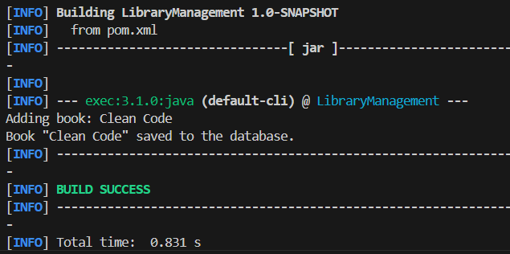

## Exercise 4: Creating and Configuring a Maven Project Scenario:

You need to set up a new Maven project for the library management application and add Spring dependencies.

## Steps:

1. Create a New Maven Project:
   * Create a new Maven project named LibraryManagement.
2. Add Spring Dependencies in pom.xml:
   * Include dependencies for Spring Context, Spring AOP, and Spring WebMVC.
3. Configure Maven Plugins:
   * Configure the Maven Compiler Plugin for Java version 1.8 in the pom.xml file.

# SOLUTION

## pom.xml

<project xmlns="<http://maven.apache.org/POM/4.0.0>" xmlns:xsi="<http://www.w3.org/2001/XMLSchema-instance>" xsi:schemaLocation="<http://maven.apache.org/POM/4.0.0>

<http://maven.apache.org/xsd/maven-4.0.0.xsd>">

<modelVersion>4.0.0</modelVersion>

<groupId>com.library</groupId>

<artifactId>LibraryManagement</artifactId>

<version>1.0-SNAPSHOT</version>

<dependencies>

<!-- Spring Context -->

<dependency>

<groupId>org.springframework</groupId>

<artifactId>spring-context</artifactId>

<version>5.3.33</version>

</dependency>

<!-- Spring AOP -->

<dependency>

<groupId>org.springframework</groupId>

<artifactId>spring-aop</artifactId>

<version>5.3.33</version>

</dependency>

<!-- Spring WebMVC -->

<dependency>

<groupId>org.springframework</groupId>

<artifactId>spring-webmvc</artifactId>

<version>5.3.33</version>

</dependency>

<!-- JUnit -->

<dependency>

<groupId>junit</groupId>

<artifactId>junit</artifactId>

<version>4.13.2</version>

<scope>test</scope>

</dependency>

</dependencies>

<build>

<plugins>

<!-- Maven Compiler Plugin -->

<plugin>

<groupId>org.apache.maven.plugins</groupId>

<artifactId>maven-compiler-plugin</artifactId>

<version>3.8.1</version>

<configuration>

<source>1.8</source>

<target>1.8</target>

</configuration>

</plugin>

<!-- Exec Plugin to run main class -->

<plugin>

<groupId>org.codehaus.mojo</groupId>

<artifactId>exec-maven-plugin</artifactId>

<version>3.1.0</version>

<executions>

<execution>

<goals>

<goal>java</goal>

</goals>

</execution>

</executions>

</plugin>

</plugins>

</build>

</project>

## MainApp.java

package com.library.main;

import com.library.service.BookService;

import org.springframework.context.ApplicationContext;

import org.springframework.context.support.ClassPathXmlApplicationContext;

public class MainApp {

public static void main(String[] args) { ApplicationContext context = new

ClassPathXmlApplicationContext("applicationContext.xml");

BookService bookService = (BookService) context.getBean("bookService"); bookService.addBook("Clean Code");

}

}

## BookService.java

package com.library.service;

import com.library.repository.BookRepository; public class BookService {

private BookRepository bookRepository;

public void setBookRepository(BookRepository bookRepository) { this.bookRepository = bookRepository;

}

public void addBook(String bookName) { System.out.println("Adding book: " + bookName); bookRepository.saveBook(bookName);

}

}

## BookRepository.java

package com.library.repository;

public class BookRepository {

public void saveBook(String bookName) {

System.out.println("Book \"" + bookName + "\" saved to the database.");

}

}

## applicationContext.xml

<?xml version="1.0" encoding="UTF-8"?>

<beans xmlns="<http://www.springframework.org/schema/beans>" xmlns:xsi="<http://www.w3.org/2001/XMLSchema-instance>" xsi:schemaLocation=" <http://www.springframework.org/schema/beans> <http://www.springframework.org/schema/beans/spring-beans.xsd>">

<bean id="bookRepository" class="com.library.repository.BookRepository" />

<bean id="bookService" class="com.library.service.BookService">

<property name="bookRepository" ref="bookRepository" />

</bean>

</beans>

# OUTPUT

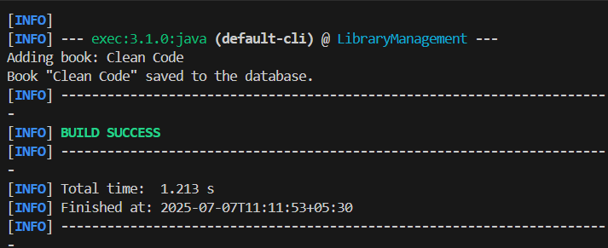

## Spring Data JPA With Hibernate

**Hands On 1:Spring Data JPA - Quick Example** **Country.java** src/main/java/com/cognizant/ormlearn/model/Country.java

package com.cognizant.ormlearn.model; import javax.persistence.Column; import javax.persistence.Entity;

import javax.persistence.Id; import javax.persistence.Table;

@Entity

@Table(name = "country") public class Country {

@Id

@Column(name = "co_code") private String code;

@Column(name = "co_name") private String name;

public String getCode() { return code;

}

public void setCode(String code) { this.code = code;

}

public String getName() { return name;

}

public void setName(String name) { this.name = name;

}

@Override

public String toString() {

return "Country [code=" + code + ", name=" + name + "]";

}

}

**CountryRepository.java** src/main/java/com/cognizant/ormlearn/repository/CountryRepository.java package com.cognizant.ormlearn.repository;

import com.cognizant.ormlearn.model.Country;

import org.springframework.data.jpa.repository.JpaRepository; import org.springframework.stereotype.Repository;

@Repository

public interface CountryRepository extends JpaRepository<Country, String> {

}

**CountryService.java** src/main/java/com/cognizant/ormlearn/service/CountryService.java package com.cognizant.ormlearn.service;

import com.cognizant.ormlearn.model.Country;

import com.cognizant.ormlearn.repository.CountryRepository; import org.springframework.beans.factory.annotation.Autowired; import org.springframework.stereotype.Service;

import org.springframework.transaction.annotation.Transactional; import java.util.List;

@Service

public class CountryService {

@Autowired

private CountryRepository countryRepository;

@Transactional

public List<Country> getAllCountries() { return countryRepository.findAll();

}

}

**OrmLearnApplication.java** src/main/java/com/cognizant/ormlearn/OrmLearnApplication.java package com.cognizant.ormlearn;

import com.cognizant.ormlearn.model.Country;

import com.cognizant.ormlearn.service.CountryService; import org.slf4j.Logger;

import org.slf4j.LoggerFactory;

import org.springframework.boot.SpringApplication;

import org.springframework.boot.autoconfigure.SpringBootApplication; import org.springframework.context.ApplicationContext;

import java.util.List; @SpringBootApplication

public class OrmLearnApplication {

private static final Logger LOGGER = LoggerFactory.getLogger(OrmLearnApplication.class);

private static CountryService countryService;

public static void main(String[] args) { ApplicationContext context =

SpringApplication.run(OrmLearnApplication.class, args); countryService = context.getBean(CountryService.class);

testGetAllCountries();

}

private static void testGetAllCountries() { LOGGER.info("Start");

List<Country> countries = countryService.getAllCountries(); LOGGER.debug("countries={}", countries);

LOGGER.info("End");

}

}

## application.properties

src/main/resources/application.properties

# Spring log levels logging.level.org.springframework=info logging.level.com.cognizant=debug

# Hibernate logs logging.level.org.hibernate.SQL=trace logging.level.org.hibernate.type.descriptor.sql=trace

# Console log format

logging.pattern.console=%d{dd-MM-yy} %d{HH:mm:ss.SSS} %-20.20thread

%5p %-25.25logger{25} %25M %4L %m%n

# MySQL database configuration

spring.datasource.driver-class-name=com.mysql.cj.jdbc.Driver spring.datasource.url=jdbc:mysql://localhost:3306/ormlearn spring.datasource.username=root spring.datasource.password=*****

# Hibernate dialect and mode spring.jpa.hibernate.ddl-auto=validate

spring.jpa.properties.hibernate.dialect=org.hibernate.dialect.MySQL5Dialect

## SQL: Create & Insert in country Table

create table country (

co_code varchar(2) primary key, co_name varchar(50)

);

insert into country values ('IN', 'India');

insert into country values ('US', 'United States of America');

# OUTPUT

## Hands On 4-Difference between JPA, Hibernate and Spring Data JPA Java Persistence API (JPA)

* JPA is a Java specification (JSR 338) for accessing, persisting, and managing data between Java objects and relational databases.
* It provides a standard API for ORM (Object Relational Mapping) in Java.
* JPA is only a set of interfaces; it does not provide implementation on its own.
* You need an implementation like Hibernate or EclipseLink to use JPA.
* JPA defines annotations like @Entity, @Table, @Id, etc., for mapping Java classes to database tables.

## Hibernate

* Hibernate is a concrete implementation of the JPA specification.
* It is an ORM tool that automatically handles object-database mapping.
* Hibernate includes features like lazy loading, caching, dirty checking, and automatic schema generation.
* It can be used with or without JPA.
* When used with JPA, Hibernate acts as the engine that performs the actual database operations.

## Spring Data JPA

* Spring Data JPA is a part of the Spring Framework that builds on top of JPA.
* It does not implement JPA, but simplifies JPA-based data access using repository abstraction.
* It removes boilerplate code for common CRUD operations.
* Spring Data JPA automatically implements repository interfaces based on naming conventions.
* It also manages transactions and integrates easily with Spring Boot and Spring configuration.
* Spring Data JPA usually works with Hibernate under the hood as the default JPA provider.

## Code Comparison

**Using Hibernate (Manual Approach):**

public Integer addEmployee(Employee employee) { Session session = factory.openSession(); Transaction tx = null;

Integer employeeID = null;

try {

tx = session.beginTransaction();

employeeID = (Integer) session.save(employee); tx.commit();

} catch (HibernateException e) { if (tx != null) tx.rollback(); e.printStackTrace();

} finally { session.close();

}

return employeeID;

}

This approach requires manually opening a session, starting a transaction, saving the entity, and handling rollback or commit.

## Using Spring Data JPA : EmployeeRepository.java:

public interface EmployeeRepository extends JpaRepository<Employee, Integer>

{

}

## EmployeeService.java:

@Autowired

private EmployeeRepository employeeRepository;

@Transactional

public void addEmployee(Employee employee) { employeeRepository.save(employee);

}

In this approach, all the boilerplate code is removed. Spring handles the session, transaction, and persistence automatically.

## Summary

JPA is just a specification. Hibernate is one implementation of JPA that provides the actual functionality to perform ORM operations. Spring Data JPA is a convenient abstraction over JPA and Hibernate that makes development faster and cleaner by reducing repetitive code and providing ready-to-use repository interfaces.